**Assignement-4**

1. Write a program to perform the following task:
2. Addition of two square matrices

b. Subtraction of two square matrices

c. Multiplication of two square matrices

d. Determinant of a square matrix.

e. Inverse of a square matrix (if the determinant is non zero)

Note: Use a menu-driven program using do..while loop and switch case

Code for (a), (b), (c):

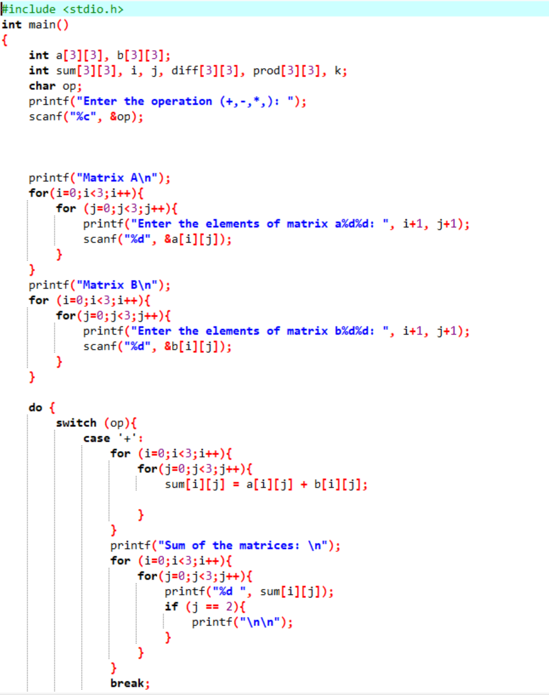

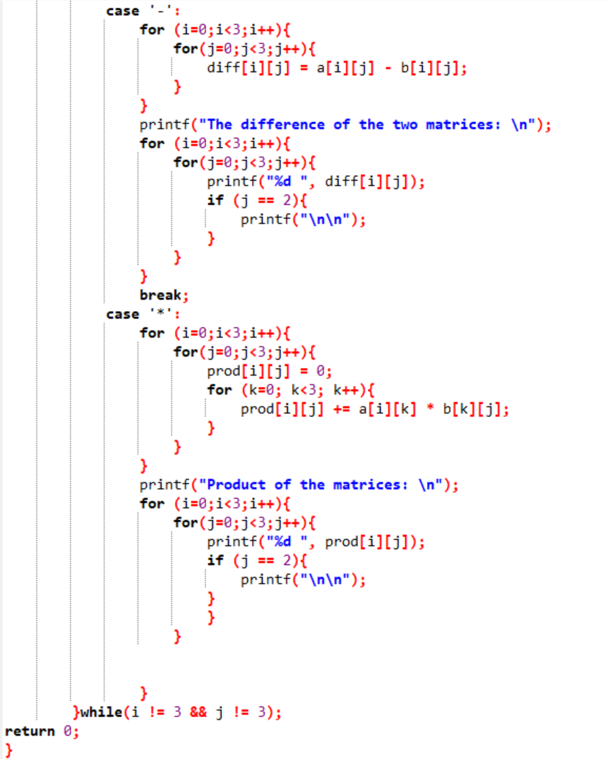

**CODE FOR (D), (E):**

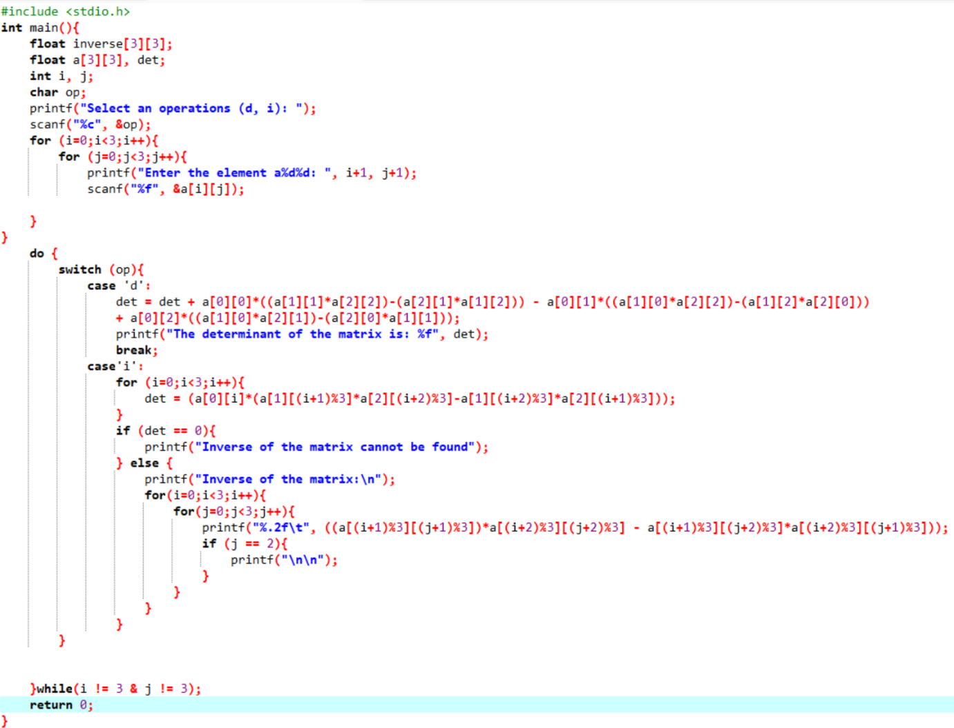

**OUTPUT FOR (A), (B), (C):**

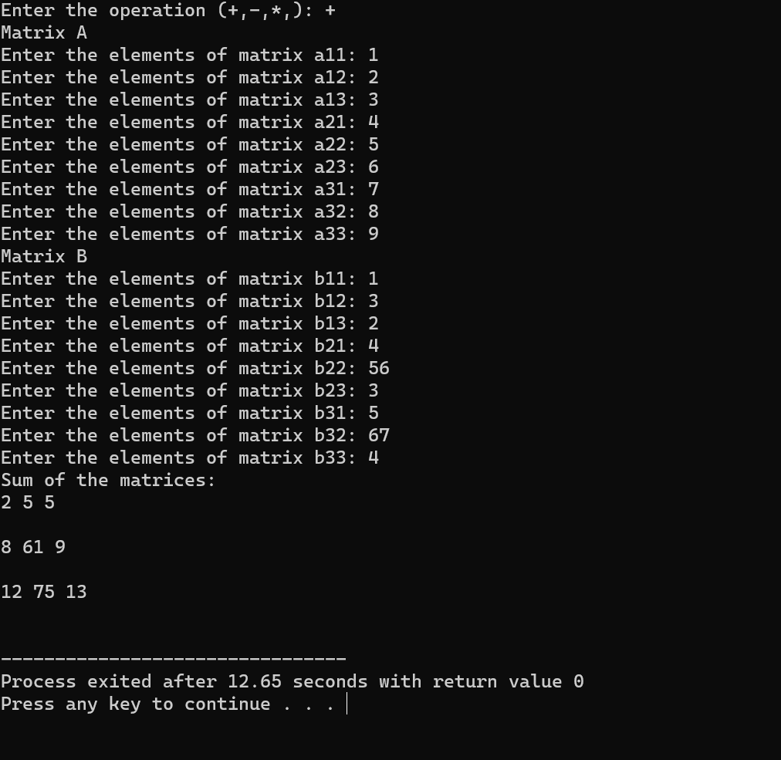

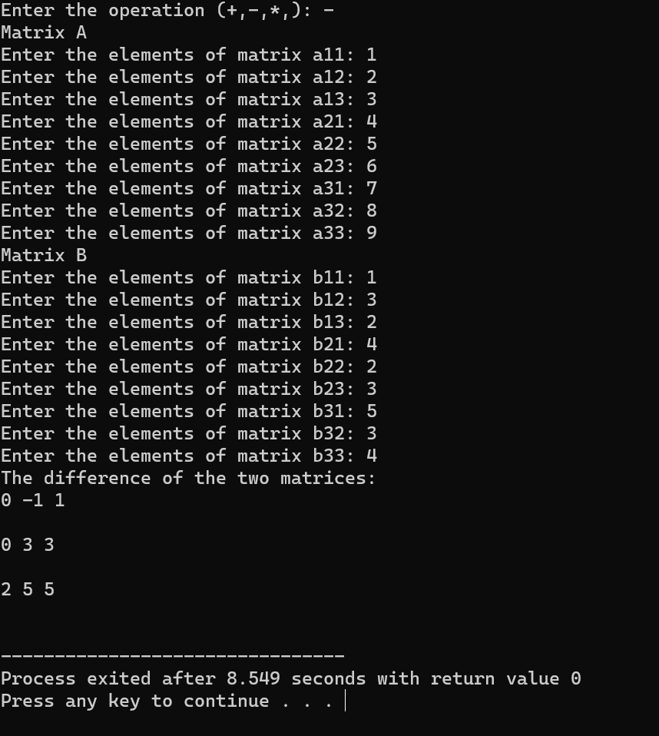

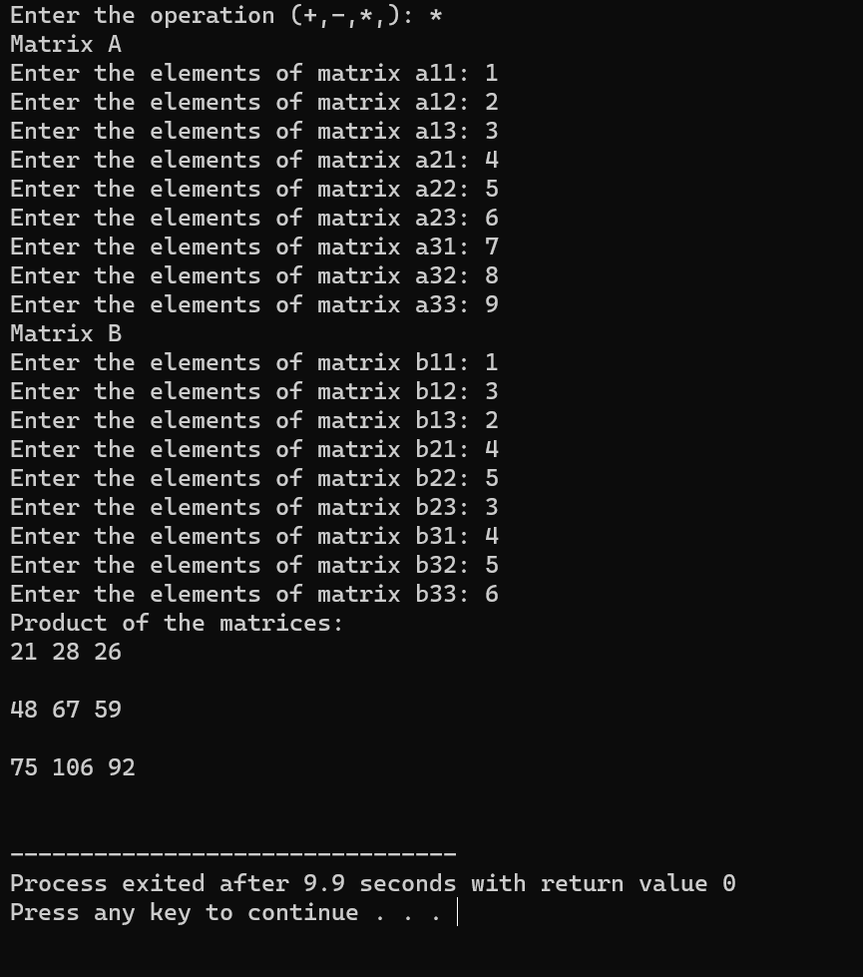

**Output for (d), (e):**

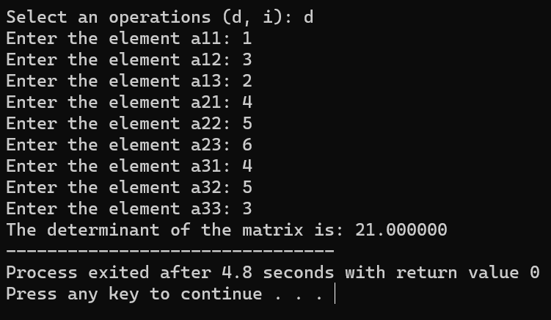

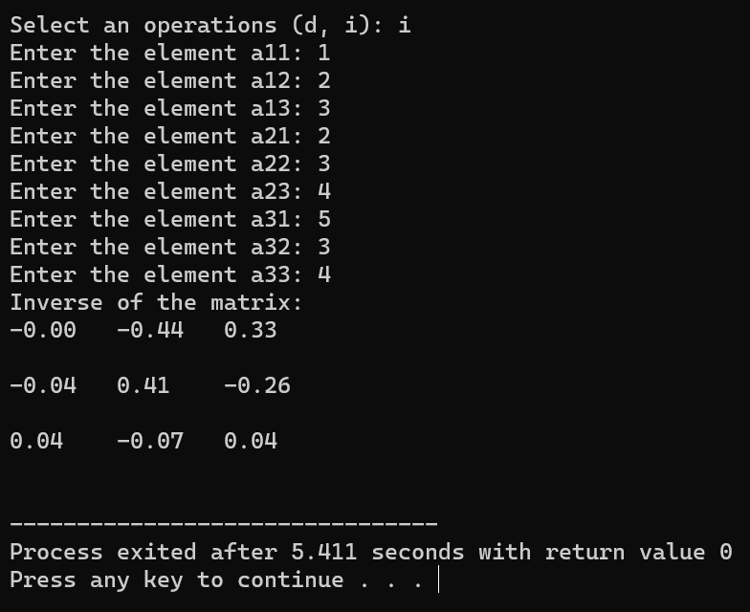

1. Write a C program using functions to perform the following tasks:

a) To convert the binary equivalent of a decimal number

b) To find the power of a number.

c) To reverse the number inputted by the user.

Note: Use a menu-driven program using do..while loop and switch case

CODE:

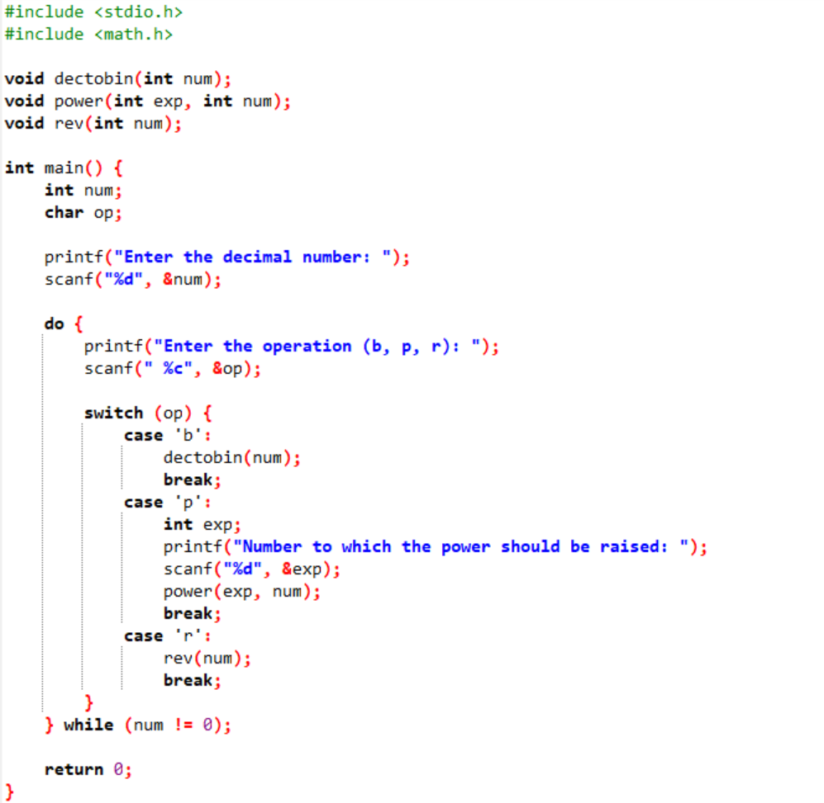

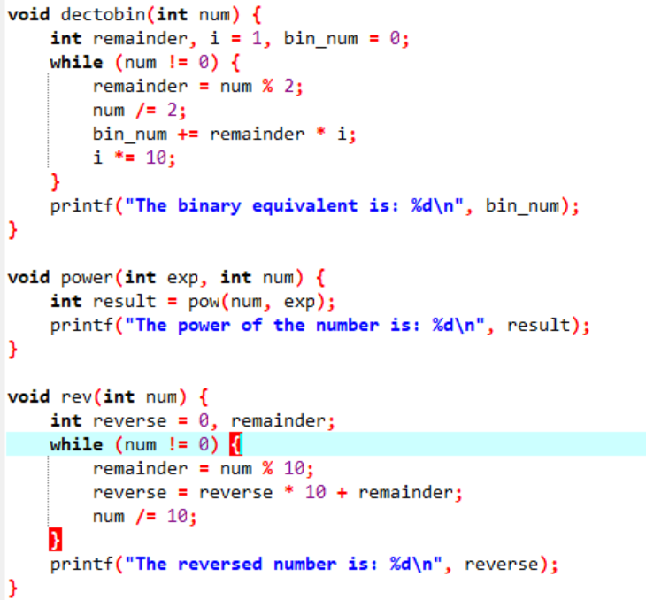

**Output:**

